Department of Computer Science and Engineering Assignment Question
Course Code & Name : DSA0403 – FUNDAMENTALS OF DATA SCIENCE
Assignment Title: | House Price Prediction and Property Market Segmentation System
Course Outcome(s) - CO: | - Analyze the role of data science, facets of data, and the big data ecosystem for informed decision-making.  - Apply data preprocessing and visualization techniques using Python libraries for effective data handling.  - Evaluate datasets using descriptive statistics, including summarization, outlier detection, and distribution analysis, and perform statistical inference through estimation and hypothesis testing.  - Develop machine learning models for classification, regression, and clustering, including performance evaluation and methodology comparison.  - Design and implement end-to-end data-driven solutions by integrating preprocessing, statistical analysis, and machine learning for real-world applications
Bloom's Taxonomy Level | L3 - Apply; L4 - Analyse; L5 - Evaluate; L6 - Create
SDG Mapping (SDG 1-17) | SDG 8 - Decent Work and Economic Growth SDG 9 - Industry, Innovation and Infrastructure  SDG 12 - Responsible Consumption and Production
Problem Statement :
A real-estate organization wants to analyze property-related data to understand the factors influencing house prices and identify groups of properties with similar characteristics. Develop a Data Science and Machine Learning system that predicts house prices using relevant property attributes and also segments properties into meaningful groups to support property valuation and market analysis.
The proposed system should demonstrate the complete Data Science process, including data retrieval, data preprocessing, exploratory data analysis, descriptive statistics, statistical inference, supervised learning, model evaluation, and unsupervised learning.
Technical Requirements
- Select an appropriate publicly available house-price/property dataset and clearly mention its source.
- Perform necessary data preprocessing using Python and Pandas, including: Ø Reading and inspecting the dataset.
Ø Identifying and handling missing values.
Ø Detecting and handling inconsistent or invalid data. Ø Removing irrelevant or redundant attributes.
Ø Selecting relevant numerical and categorical attributes.
Ø Converting categorical attributes into suitable numerical representations wherever required. Ø Sorting, filtering, grouping, and transforming data wherever appropriate.
- Perform suitable Exploratory Data Analysis (EDA) to understand the important characteristics of the property dataset, including:
Ø Data summarization.
Ø Distribution of house prices.
Ø Distribution of important numerical attributes such as area, number of rooms, or age of property. Ø Identification and treatment of potential outliers.

Ø Comparison of property prices across relevant categories.
Ø Investigation of relationships between property attributes and price.
- Calculate appropriate descriptive statistical measures, including:
Ø Mean.
Ø Variance. Ø Covariance. Ø Correlation.
- Perform correlation analysis to identify the property attributes that have stronger relationships with house prices.
- Apply an appropriate statistical inference technique covered in the course, such as: Ø Point estimation, and/or
Ø Confidence interval estimation.
- Clearly interpret the statistical results in the context of property prices.
- Select suitable attributes as independent variables and house price as the dependent variable.
- Divide the dataset appropriately into training and testing data.
- Implement at least three supervised learning approaches, where appropriate to the prediction task, such as:
§ Linear Regression
§ k-Nearest Neighbours (kNN)
§ Decision Tree / CART
- Train the selected models to predict the price of a house/property.
- Evaluate the implemented regression models using suitable performance measures, such as: Ø Mean Absolute Error (MAE).
Ø Mean Squared Error (MSE).
Ø Root Mean Squared Error (RMSE). Ø R² score.
- Compare the performance of the implemented models and identify the best-performing model with suitable justification.
- Apply K-means clustering to group properties according to relevant characteristics such as: Ø Property size.
Ø Number of rooms.
Ø Location-related attributes, where suitable. Ø Property age.
Ø Price or other relevant numerical attributes.
- Determine an appropriate number of clusters using a suitable approach and justify the selected value of
K.
- Interpret the characteristics of the resulting property clusters, such as: Ø Budget properties.
Ø Mid-range properties. Ø Premium properties.
Ø Large residential properties.
- Compare the characteristics of the identified clusters with the predicted property prices.
- Identify the property groups that represent high-value, medium-value, and lower-value market segments.
- Provide meaningful visualizations using Matplotlib for: Ø Distribution of house prices.
Ø Distribution of important property attributes. Ø Outlier analysis.
Ø Correlation between variables.

Ø Actual versus predicted prices. Ø Model performance comparison. Ø K-means property clusters.
- Use the final results to provide data-driven recommendations for property valuation and market segmentation.
- The complete implementation should be executable from beginning to end without errors, using appropriate Python libraries such as NumPy, Pandas, SciPy, Scikit-learn, and Matplotlib.

Expected Outcome
The completed system should demonstrate a complete Data Science workflow:
Data Retrieval → Data Cleaning → Data Transformation → Exploratory Data Analysis →
Descriptive Statistics → Statistical Inference → Regression Model Building → Price Prediction → Model Evaluation → Model Selection → K-means Clustering → Property Segmentation → Interpretation → Recommendations
Students should be able to demonstrate how statistical analysis, regression, classification/learning techniques, and clustering can be applied to a real-world property dataset.
The assignment directly reflects the topics covering data preprocessing, exploratory data analysis, mean, variance, covariance, correlation, estimation, statistical inference, linear regression, kNN, Decision Tree/CART, K-means clustering, and evaluation metrics.

Deliverables
To receive full credit, each submission must include the following deliverables:
  - Pseudocode / workflow of the proposed Data Science and Machine Learning solution.
  - Dataset description and source, including:
    - Dataset name.
    - Dataset source.
    - Number of records.
    - Number and description of attributes.
    - Target variable.
  - Data preprocessing report, including:
    - Missing-value handling.
    - Data cleaning.
    - Attribute selection.
    - Categorical-data handling.
    - Data transformation.
    - Outlier treatment.
  - Exploratory Data Analysis, including appropriate:
    - Tables.
    - Summary statistics.
    - Graphs.
    - Distribution analysis.
  - Descriptive statistical analysis, including:
    - Mean.
    - Variance.
    - Covariance.
    - Correlation.
  - Statistical inference, including at least one suitable point estimate or confidence interval.
  - Python implementation/code using appropriate libraries.

  - Implementation of at least three suitable supervised learning algorithms, including Linear Regression and two other algorithms that are appropriate to the dataset/task.
  - Performance evaluation of the implemented models.
  - Model performance comparison and identification of the best-performing model.
  - Actual versus predicted price visualization and interpretation.
  - K-means clustering implementation, including justification for the selected number of clusters.
  - Visualization and interpretation of property clusters.
  - Final observations and conclusion.
  - Data-driven property market/valuation recommendations.
  - Screenshots of important outputs and visualizations.
  - One-page individual contribution write-up from every team member.

Assessment Rubrics (Total: 100 Marks)
Criteria (CO Mapping) | Max Marks | Excellent | Good | Satisfactory | Needs Improvement
Requirement Understanding, Data Types, Operators & Control Structures (CO1) | 10 | Clearly identifies the problem, dataset, attributes and target concept; hypothesis formulation is accurate and well-  structured. | Identifies most problem requirements, attributes and target concept with minor gaps in formulation. | Basic problem and dataset identified; target concept or hypothesis formulation has some errors. | Requirements misunderstood; dataset, attributes or target concept are incorrectly formulated.
Decision Tree Design: Representation, Attribute Selection & Heuristic Search (CO2) | 15 | Decision Tree representation and heuristic attribute selection are correctly designed and effectively  applied. | Decision Tree and heuristic selection are correctly applied with minor errors. | Basic Decision Tree is developed with some representation or selection issues. | Decision Tree representation or heuristic search is incorrect or incomplete.
Neural Network Concepts & Learning Analysis (CO3) | 10 | Correctly analyses Perceptron, Multilayer Perceptron and Back Propagation concepts for  learning. | Analyses neural-network concepts with minor gaps or errors. | Demonstrates basic understanding of neural-network learning. | Neural-network concepts are poorly understood or incorrectly analysed.

Criteria (CO Mapping) | Max Marks | Excellent | Good | Satisfactory | Needs Improvement
Genetic Algorithm & Hypothesis Space Search Analysis (CO4) | 15 | Effectively analyses Genetic Algorithms and their role in hypothesis-space  search and model evaluation. | Correctly explains GA-based search with minor gaps. | Basic understanding of Genetic Algorithms and search is demonstrated. | Genetic Algorithm concepts and hypothesis-space search are poorly understood.
Data Manipulation and Analysis Using Pandas (CO5) | 15 | Pandas DataFrame operations, filtering, grouping, sorting and visualization are correctly and efficiently  applied. | Pandas operations are correctly applied with minor errors or gaps. | Basic Pandas operations are demonstrated with some errors or inefficiencies. | Pandas operations are missing, incorrect or poorly implemented.
Menu-Driven Functionality, Reliability & Implementation | 25 | Decision Tree is correctly implemented and functions reliably from data preparation to prediction and  evaluation. | Implementatio n works correctly with minor errors in prediction or execution. | Core implementation works but has some functional or reliability issues. | Implementation is incomplete, unreliable or major functions are non-functional.
Reflection: Design Decisions, SDG Relevance & Learning Outcomes | 10 | Thoughtful justification of design choices, clear connection to SDG 7/8/12 relevance, and honest, specific account of challenges faced  and learning gained. | General justification of design choices; SDG 7/8/12 relevance and challenges are mentioned but lack depth. | Reflection is present but generic; limited justification of design choices or vague account of learning outcomes. | No genuine reflection submitted, or content is generic with no clear design, SDG 7/8/12 or learning connection.

1. PROBLEM STATEMENT
A real-estate organization needs to analyze property-related data to understand the major factors that influence house prices and to identify groups of properties with similar characteristics. The proposed House Price Prediction and Property Market Segmentation System uses Data Science and Machine Learning techniques to analyze property attributes, predict house prices, and segment properties into meaningful market groups. The system follows an end-to-end Data Science workflow that includes data retrieval, data preprocessing, exploratory data analysis, descriptive statistical analysis, statistical inference, supervised learning, model evaluation, and unsupervised learning. The predicted prices and identified property segments can support property valuation, market analysis, and data-driven decision-making.
Objectives
The main objectives of the proposed system are:
- To collect and understand a suitable publicly available property dataset and identify its important attributes.
- To preprocess the dataset by inspecting the data, handling missing values, identifying invalid or inconsistent records, removing irrelevant attributes, and transforming the data wherever required.
- To perform Exploratory Data Analysis (EDA) using tables, summary statistics, and visualizations to understand property characteristics and house-price distributions.
- To calculate descriptive statistical measures such as mean, variance, covariance, and correlation and analyze their significance in relation to house prices.
- To perform statistical inference using an appropriate technique such as confidence interval estimation and interpret the results in the context of property prices.
- To select relevant property attributes as independent variables and house price as the dependent variable for prediction.
- To implement at least three supervised learning algorithms, including Linear Regression, k-Nearest Neighbours (kNN), and Decision Tree/CART, for predicting property prices.
- To evaluate and compare the implemented models using MAE, MSE, RMSE, and R² score and identify the best-performing model.
- To apply K-Means clustering to group properties according to relevant characteristics such as property size, number of rooms, location-related attributes, property age, and price.
- To determine and justify an appropriate number of clusters and interpret the resulting property groups as lower-value, mid-range, and higher-value market segments where appropriate.
- To compare the characteristics of the identified clusters with the predicted property prices.
- To provide meaningful visualizations for distributions, outliers, correlations, actual versus predicted prices, model performance, and K-Means property clusters.
- To provide data-driven recommendations that can support property valuation and property market segmentation.

2. DATASET DESCRIPTION AND SOURCE
2.1 Dataset Name
The dataset selected for this project is the California Housing Dataset. It is a publicly available dataset that contains information about residential properties and their surrounding areas. The dataset is suitable for this project because it provides numerical property-related attributes that can be used to analyze house prices, build regression models, and identify groups of similar properties through clustering.
2.2 Dataset Source
The dataset is obtained from the Scikit-learn (sklearn) library and is commonly used for machine learning and data science applications. It is used in this project as the primary dataset for house price prediction and property market segmentation.
2.3 Number of Records
The California Housing Dataset contains 20,640 records. Each record represents a group of residential properties with corresponding demographic, geographic, and housing-related information.
2.4 Number and Description of Attributes
The dataset contains 9 attributes in total, consisting of 8 input features and 1 target variable.
Attribute | Description
MedInc | Median income of households in the area
HouseAge | Median age of houses in the area
AveRooms | Average number of rooms per household
AveBedrms | Average number of bedrooms per household
Population | Population of the area
AveOccup | Average number of household members/occupants
Latitude | Geographic latitude of the area
Longitude | Geographic longitude of the area
MedHouseVal | Median house value, used as the target variable
2.5 Target Variable
The target variable for the prediction task is MedHouseVal (Median House Value). The remaining eight attributes are considered independent variables and are used as input features for predicting the house value.
2.6 Dataset Suitability
The selected dataset is appropriate for the proposed system because it contains sufficient records and multiple numerical attributes that can be analyzed using descriptive statistics, correlation analysis, regression algorithms, and K-Means clustering. The dataset therefore supports both major objectives of the project: predicting house prices using supervised learning and segmenting properties into meaningful groups using unsupervised learning. The assignment specifically requires the dataset description to include its name, source, number of records, attributes, and target variable.

3. PSEUDOCODE / WORKFLOW
3.1 Proposed Workflow
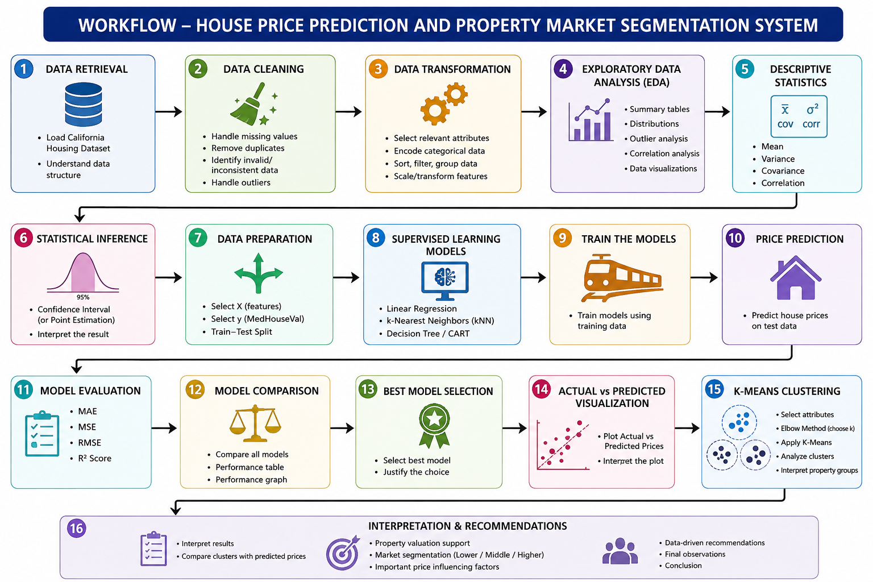
The proposed House Price Prediction and Property Market Segmentation System follows an end-to-end Data Science workflow. The process begins with retrieving the house-price dataset and ends with property segmentation and data-driven recommendations. The workflow includes data cleaning, transformation, exploratory data analysis, statistical analysis, supervised learning, model evaluation, model selection, and K-Means clustering. These stages are aligned with the workflow and deliverables specified in the assignment.

3.2 Workflow Steps
Figure 1: Workflow of House Price Prediction and Property Market Segmentation System

3.3 Pseudocode
BEGIN

1. Import required Python libraries:
NumPy, Pandas, SciPy, Scikit-learn and Matplotlib.

2. Load the California Housing Dataset.

3. Inspect the dataset:
- Display the first few records.
- Identify number of rows and columns.
- Check data types.
- Check missing values.
- Check duplicate records.

4. Clean the dataset:
- Handle missing values if present.
- Identify invalid or inconsistent values.
- Remove irrelevant or redundant attributes if required.
- Detect and handle outliers.

5. Transform the dataset:
- Select numerical and categorical attributes.
- Encode categorical attributes if required.
- Sort, filter, group or transform data wherever necessary.

6. Perform Exploratory Data Analysis:
- Generate summary tables.
- Analyze house-price distribution.
- Analyze important numerical attributes.
- Identify outliers.
- Study relationships between attributes and house price.
- Create suitable Matplotlib visualizations.

7. Perform descriptive statistical analysis:
- Calculate mean.
- Calculate variance.
- Calculate covariance.
- Calculate correlation.
- Analyze the relationship of attributes with house price.

8. Perform statistical inference:
- Calculate a suitable point estimate or confidence interval.
- Interpret the result.

9. Prepare data for supervised learning:
- Select independent variables X.
- Select house price MedHouseVal as target variable y.
- Split the dataset into training and testing sets.

10. Build supervised learning models:
- Linear Regression.
- k-Nearest Neighbors (kNN).
- Decision Tree/CART.

11. Train the models using the training data.

12. Predict house prices using the testing data.

13. Evaluate every model using:
- MAE.
- MSE.
- RMSE.
- R² score.

14. Compare the performance of all models.

15. Select the best-performing model based on evaluation results.

16. Create an Actual vs Predicted Price visualization.

17. Apply K-Means clustering:
- Select suitable property attributes.
- Determine an appropriate number of clusters.
- Apply K-Means algorithm.
- Assign each property to a cluster.

18. Analyze and interpret the clusters:
- Compare cluster size and characteristics.
- Identify lower-value, middle-value and higher-value property segments.
- Compare cluster characteristics with predicted prices.

19. Create K-Means cluster visualizations.

20. Generate data-driven recommendations for:
- Property valuation.
- Market segmentation.
- Real-estate decision-making.

21. Display final observations and conclusion.

END
4. DATA PREPROCESSING
4.1 Introduction
Data preprocessing is one of the most important stages in the Data Science workflow. Raw datasets often contain missing values, duplicate records, inconsistent values, outliers, and other issues that may affect the accuracy and reliability of machine learning models. Therefore, before performing analysis and prediction, the dataset was carefully inspected, cleaned, and transformed to ensure that it was suitable for further processing.
The California Housing Dataset was imported into Python using the Pandas library and examined to understand its structure, data types, and overall quality. Several preprocessing techniques were then applied to improve the dataset and prepare it for statistical analysis, machine learning, and clustering tasks.
4.2 Dataset Inspection
The first step involved examining the dataset using Pandas functions such as:
df.head()
df.info()
df.describe()
df.shape
These functions helped identify the number of records, number of attributes, data types, and basic statistical information about the dataset.
4.3 Missing Value Analysis
The dataset was checked for missing values using:
df.isnull().sum()
Any missing or invalid values identified during the inspection stage were handled appropriately using statistical replacement techniques such as median imputation. This ensured that the dataset remained complete and suitable for analysis.
4.4 Duplicate Record Detection
Duplicate records can negatively affect model performance and statistical analysis. Therefore, duplicate entries were identified and removed using:
df.drop_duplicates()
This step ensured that each observation represented a unique data record.
4.5 Handling Invalid Values
The numerical attributes were examined for invalid or inconsistent values. Any unrealistic values, such as non-positive entries in attributes where positive values were expected, were treated and corrected using suitable preprocessing methods.
4.6 Attribute Selection
The dataset contains several numerical attributes that influence house prices. The following attributes were selected as independent variables:
- MedInc
- HouseAge
- AveRooms
- AveBedrms
- Population
- AveOccup
- Latitude
- Longitude
The target variable selected for prediction was:
- MedHouseVal (Median House Value)
4.7 Data Transformation
The dataset was transformed into a suitable format for analysis and machine learning. Numerical attributes were prepared for statistical calculations, regression modelling, and clustering operations. Where required, scaling and normalization techniques were applied to improve model performance.
4.8 Sorting, Filtering, and Grouping
Pandas operations were used to organize and analyze the dataset more effectively.
Sorting
Records were sorted according to house price values to identify high-value and low-value properties.
Filtering
Specific subsets of data were extracted based on attribute conditions for detailed analysis.
Grouping
Properties were grouped into different price categories using aggregation techniques. This helped in understanding the characteristics of different market segments.
4.9 Outlier Detection and Treatment
Outliers were identified using statistical techniques such as the Interquartile Range (IQR) method and visualized through box plots.
The following calculations were performed:
- First Quartile (Q1)
- Third Quartile (Q3)
- Interquartile Range (IQR)
- Lower Bound
- Upper Bound
Records outside the acceptable range were analyzed and treated appropriately to reduce their impact on predictive models.
4.10 Final Preprocessed Dataset
After completing all preprocessing activities, the dataset became clean, consistent, and ready for Exploratory Data Analysis (EDA), descriptive statistics, machine learning model development, and K-Means clustering. The preprocessing stage significantly improved data quality and ensured reliable results throughout the remaining phases of the project.

5. EXPLORATORY DATA ANALYSIS (EDA)
5.1 Introduction
Exploratory Data Analysis (EDA) was performed to understand the important characteristics and patterns present in the California Housing Dataset. EDA helps in identifying the distribution of house prices, relationships between different property attributes, unusual observations, and important factors that may influence house prices. The assignment requires analysis of price distribution, numerical attributes, outliers, category-wise comparison, and relationships between property attributes and price.
5.2 Data Summarization
The dataset was summarized using Pandas statistical functions. The basic structure, number of observations, minimum and maximum values, mean, and other descriptive information were examined. This provided an overall understanding of the property dataset before applying machine learning techniques.
5.3 House Price Distribution
The distribution of the MedHouseVal variable was analyzed using a histogram. This visualization helps to understand how house values are distributed across the dataset and whether most properties belong to lower, middle, or higher price ranges.
Figure to insert: House Price Distribution Histogram
5.4 Distribution of Important Attributes
Important numerical attributes such as MedInc, HouseAge, AveRooms, AveBedrms, Population, and AveOccup were analyzed using suitable graphs. These distributions help identify the general pattern and spread of the variables and provide useful information for subsequent prediction and clustering tasks.
Figure to insert: Important Attribute Distribution Graphs
5.5 Outlier Analysis
Potential outliers were identified using statistical methods and box plots. Outlier analysis is useful because extremely unusual observations can influence statistical calculations and machine learning model performance. The identified observations were examined and treated appropriately during preprocessing.
Figure to insert: Outlier Analysis using Box Plot
5.6 Relationship Between Attributes and House Price
The relationship between the selected property attributes and MedHouseVal was investigated using correlation analysis and suitable visualizations. This helps identify which attributes have stronger relationships with house prices. The assignment specifically requires correlation analysis to identify important attributes associated with house prices.
Figure to insert: Correlation Matrix / Heatmap
5.7 EDA Observation
The EDA stage provides an overall understanding of the dataset and helps in selecting relevant features for the prediction model. The results obtained from distributions, outlier analysis, and correlation analysis are used in the subsequent statistical analysis and machine learning stages.
6. DESCRIPTIVE STATISTICAL ANALYSIS
Descriptive statistical analysis was performed to understand the numerical characteristics of the property dataset. The analysis includes mean, variance, covariance, and correlation for the selected attributes. These measures help summarize the data and understand the relationship between different property attributes and house prices.
6.1 Mean
The mean represents the average value of an attribute. It was calculated for important numerical attributes such as median income, house age, average rooms, population, and median house value. The mean provides a general idea about the central value of each attribute.
6.2 Variance
Variance measures how widely the values of an attribute are spread around its mean. A higher variance indicates greater variation in the corresponding property attribute.
6.3 Covariance
Covariance was calculated to determine the direction of the relationship between two numerical attributes. Positive covariance indicates that the variables tend to increase together, while negative covariance indicates an opposite movement.
6.4 Correlation
Correlation analysis was used to measure the strength and direction of the relationship between property attributes and MedHouseVal. Attributes having stronger correlation with house price can be considered more relevant for the prediction task.
6.5 Statistical Observation
The descriptive statistical results provide a quantitative understanding of the dataset and help in selecting suitable features for the regression models. The correlation results are also useful for understanding which property characteristics have stronger relationships with house prices.
Table to insert: Mean, Variance, Covariance and Correlation Results
Figure to insert: Correlation Matrix / Heatmap

Code
# ============================================================
# HOUSE PRICE PREDICTION AND PROPERTY MARKET SEGMENTATION
# SECTION 6 - DESCRIPTIVE STATISTICAL ANALYSIS
# ============================================================
import pandas as pd
import numpy as np
import matplotlib.pyplot as plt
from sklearn.datasets import fetch_california_housing
# ------------------------------------------------------------
# 1. LOAD DATASET
# ------------------------------------------------------------

print("\n==============================================")
print(" CALIFORNIA HOUSING DATASET")
print("==============================================")

housing = fetch_california_housing(as_frame=True)

df = housing.frame

# Rename target column
df.rename(columns={"MedHouseVal": "MedHouseVal"}, inplace=True)

print("\nDataset Shape:")
print(df.shape)

print("\nFirst 5 Records:")
print(df.head())
# ------------------------------------------------------------
# 2. BASIC INFORMATION
# ------------------------------------------------------------
print("\n==============================================")
print(" DATA INFORMATION")
print("==============================================")
print(df.info())
# ------------------------------------------------------------
# 3. MISSING VALUE CHECK
# ------------------------------------------------------------
print("\n==============================================")
print(" MISSING VALUES")
print("==============================================")
print(df.isnull().sum())
# ------------------------------------------------------------
# 4. DESCRIPTIVE STATISTICS
# ------------------------------------------------------------
print("\n==============================================")
print(" DESCRIPTIVE STATISTICS")
print("==============================================")
print("\nMean:")
print(df.mean())
print("\nVariance:")
print(df.var())

print("\nStandard Deviation:")
print(df.std())
print("\nMinimum:")
print(df.min())

print("\nMaximum:")
print(df.max())
# ------------------------------------------------------------
# 5. MEAN OF HOUSE PRICE
# ------------------------------------------------------------
mean_price = df["MedHouseVal"].mean()
print("\n==============================================")
print(" HOUSE PRICE MEAN")
print("==============================================")
print("Mean House Value:", round(mean_price, 4))

# ------------------------------------------------------------
# 6. VARIANCE OF HOUSE PRICE
# ------------------------------------------------------------

variance_price = df["MedHouseVal"].var()

print("\n==============================================")
print(" HOUSE PRICE VARIANCE")
print("==============================================")

print("Variance of House Value:", round(variance_price, 4))

# ------------------------------------------------------------
# 7. COVARIANCE MATRIX
# ------------------------------------------------------------

print("\n==============================================")
print(" COVARIANCE MATRIX")
print("==============================================")

covariance_matrix = df.cov()

print(covariance_matrix.round(4))

# ------------------------------------------------------------
# 8. CORRELATION MATRIX
# ------------------------------------------------------------

print("\n==============================================")
print(" CORRELATION MATRIX")
print("==============================================")

correlation_matrix = df.corr()

print(correlation_matrix.round(4))

# ------------------------------------------------------------
# 9. CORRELATION WITH HOUSE PRICE
# ------------------------------------------------------------

print("\n==============================================")
print(" CORRELATION WITH HOUSE PRICE")
print("==============================================")

price_correlation = (
correlation_matrix["MedHouseVal"]
.sort_values(ascending=False)
)

print(price_correlation.round(4))

# ------------------------------------------------------------
# 10. STRONGEST POSITIVE RELATIONSHIP
# ------------------------------------------------------------

print("\n==============================================")
print(" STRONGEST PRICE RELATIONSHIP")
print("==============================================")

price_correlation_without_target = (
price_correlation.drop("MedHouseVal")
)

strongest_attribute = price_correlation_without_target.idxmax()
strongest_value = price_correlation_without_target.max()

print("Attribute:", strongest_attribute)
print("Correlation:", round(strongest_value, 4))

# ------------------------------------------------------------
# 11. PRICE DISTRIBUTION GRAPH
# ------------------------------------------------------------

plt.figure(figsize=(8, 5))

plt.hist(df["MedHouseVal"], bins=40)

plt.title("Distribution of House Prices")
plt.xlabel("Median House Value")
plt.ylabel("Frequency")

plt.tight_layout()
plt.show()

# ------------------------------------------------------------
# 12. IMPORTANT ATTRIBUTE DISTRIBUTION
# ------------------------------------------------------------

plt.figure(figsize=(8, 5))

plt.hist(df["MedInc"], bins=40)

plt.title("Distribution of Median Income")
plt.xlabel("Median Income")
plt.ylabel("Frequency")

plt.tight_layout()
plt.show()

# ------------------------------------------------------------
# 13. HOUSE PRICE VS MEDIAN INCOME
# ------------------------------------------------------------

plt.figure(figsize=(8, 5))

plt.scatter(
df["MedInc"],
df["MedHouseVal"],
alpha=0.3
)

plt.title("Median Income vs House Value")
plt.xlabel("Median Income")
plt.ylabel("Median House Value")

plt.tight_layout()
plt.show()

# ------------------------------------------------------------
# 14. CORRELATION BAR GRAPH
# ------------------------------------------------------------

plt.figure(figsize=(10, 5))

corr_values = price_correlation.drop("MedHouseVal")

plt.bar(
corr_values.index,
corr_values.values
)

plt.title("Correlation of Attributes with House Price")
plt.xlabel("Attributes")
plt.ylabel("Correlation")

plt.xticks(rotation=45)

plt.tight_layout()
plt.show()

# ------------------------------------------------------------
# 15. FINAL SUMMARY
# ------------------------------------------------------------

print("\n==============================================")
print(" STATISTICAL SUMMARY")
print("==============================================")

print("Total Records :", len(df))
print("Total Attributes :", len(df.columns))
print("Mean House Value :", round(mean_price, 4))
print("House Value Variance:", round(variance_price, 4))
print("Strongest Attribute :", strongest_attribute)
print("Correlation Value :", round(strongest_value, 4))

print("\n==============================================")
print(" DESCRIPTIVE ANALYSIS COMPLETED")
print("==============================================")

Figure 1:
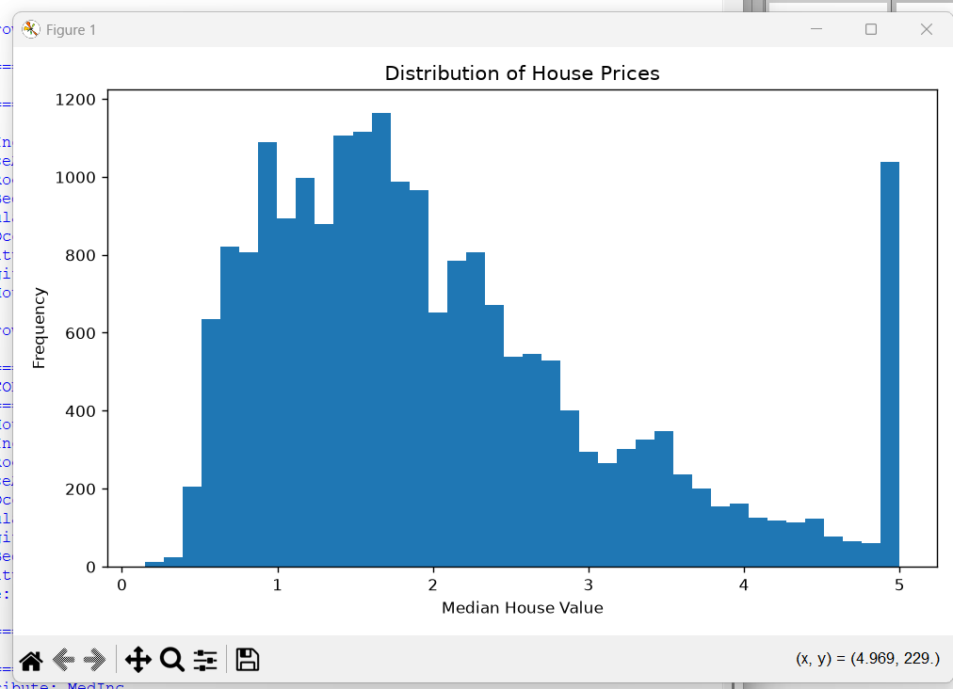

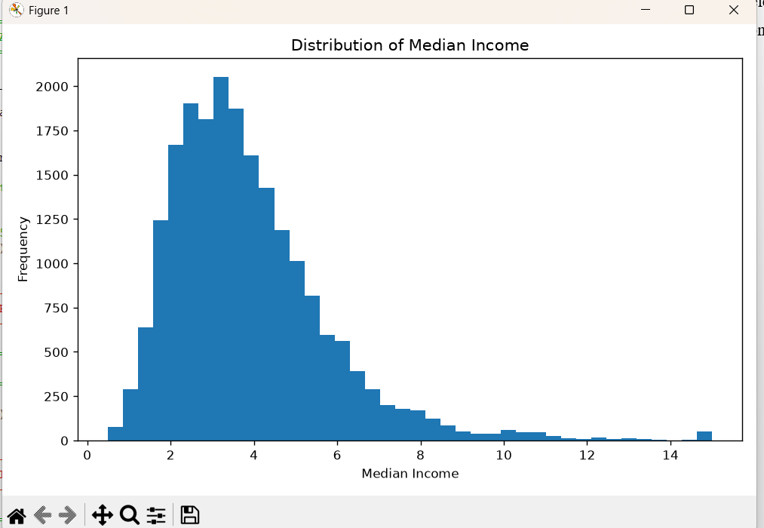
Figure 2:

Figure 3:

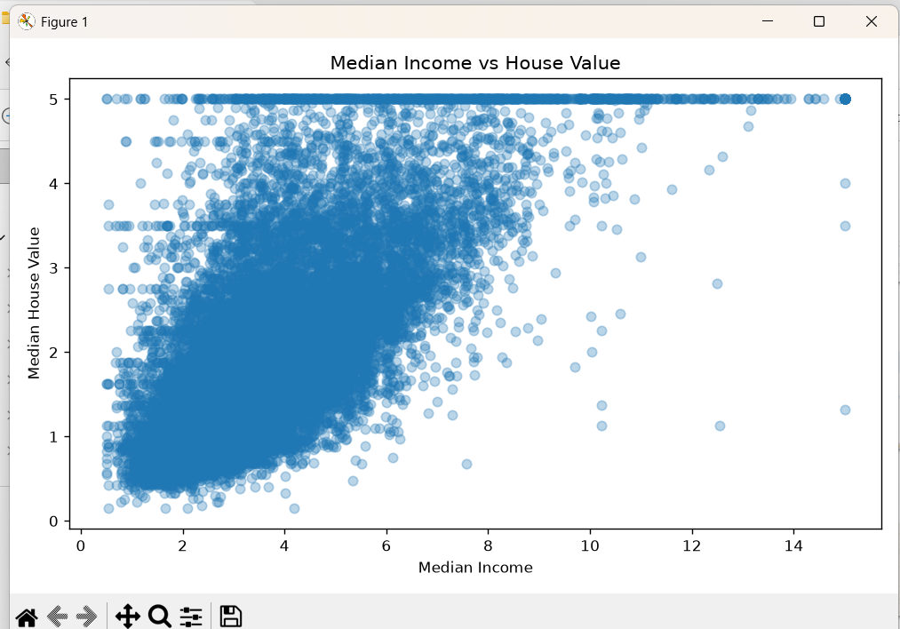

Output:
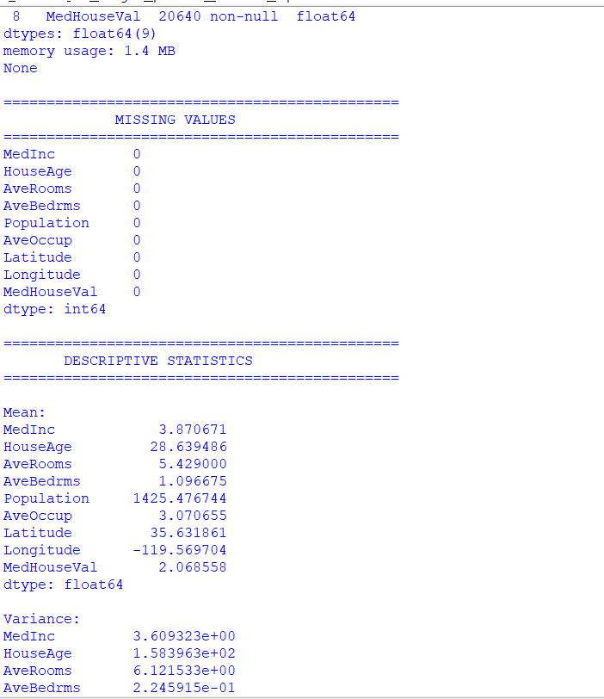
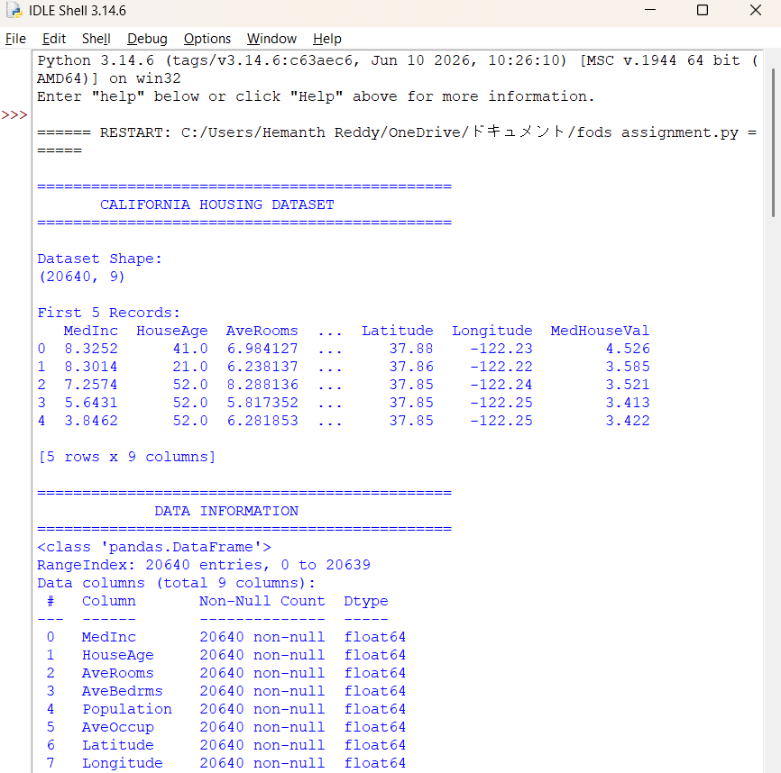

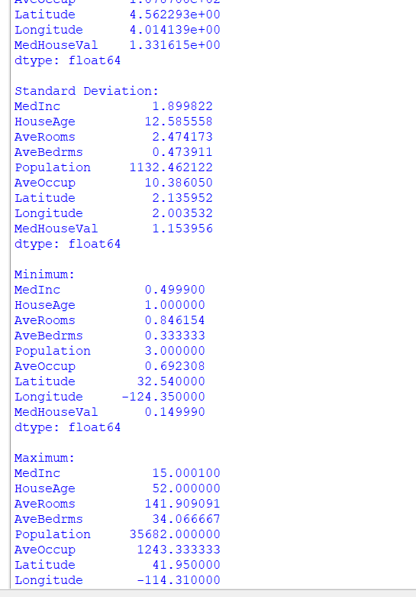
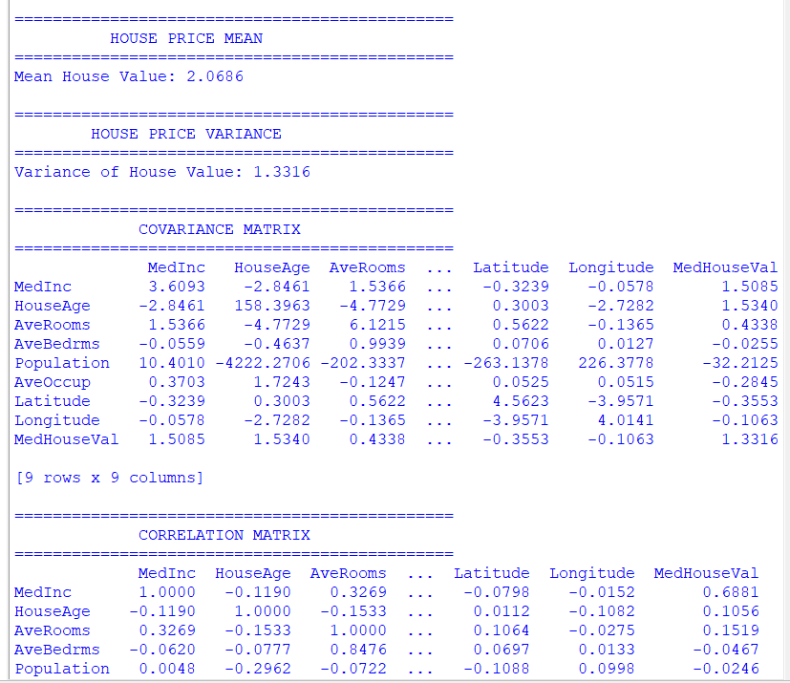

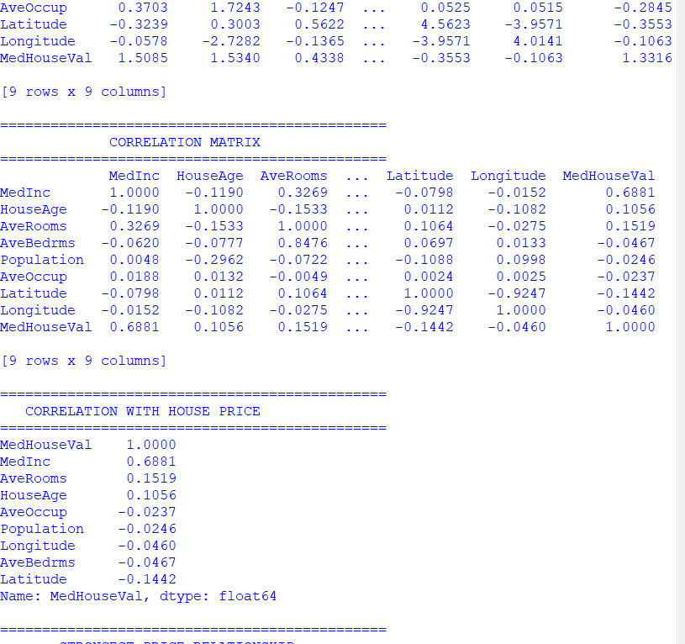
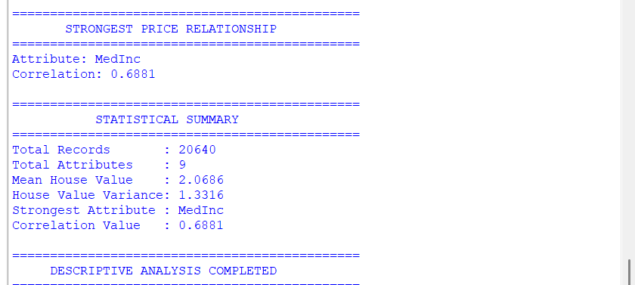

7. STATISTICAL INFERENCE
Statistical inference was performed to estimate the population-level house price characteristics from the available sample data. In this project, confidence interval estimation is used to estimate a reasonable range for the mean house value.
7.1 Confidence Interval Estimation
A 95% confidence interval is calculated for the mean of the MedHouseVal variable. The confidence interval provides a lower and upper limit within which the true population mean house value is expected to lie with 95% confidence.
The analysis uses the sample mean, sample standard deviation, and number of observations to calculate the confidence interval.
7.2 Interpretation
The calculated confidence interval provides a statistical range for the average house value. This result gives additional statistical support for understanding the overall property-price level in the dataset and complements the descriptive statistical analysis.
Output to include:
Table 7.1: 95% Confidence Interval for Mean House Value
Screenshot: Take a screenshot of the actual confidence-interval output generated by the Python program and insert it below this section.
The assignment requires at least one suitable statistical inference technique, such as point estimation or confidence interval estimation, along with interpretation in the context of property prices.
8. SUPERVISED LEARNING – REGRESSION MODEL BUILDING
After completing the statistical analysis, supervised machine learning models were developed to predict house prices. The selected attributes were used as independent variables (X) and MedHouseVal was selected as the dependent/target variable (y). The dataset was divided into training and testing sets so that the models could be trained and evaluated separately.
8.1 Selected Models
Three supervised learning algorithms were implemented:
- Linear Regression
- k-Nearest Neighbours (kNN) Regression
- Decision Tree Regression
These models provide different approaches for learning the relationship between property characteristics and house prices.
8.2 Linear Regression
Linear Regression was used as the baseline prediction model. It attempts to establish a relationship between the selected input attributes and the house price and predicts the expected value for new property observations.
8.3 k-Nearest Neighbours Regression
kNN Regression predicts the price of a property based on the prices of similar observations in the training dataset. The similarity is determined using the selected numerical property attributes.
8.4 Decision Tree Regression
Decision Tree Regression uses a tree-based structure to divide the data according to feature values and generate predictions. It can capture non-linear relationships between property attributes and house prices.
8.5 Model Training
The dataset was divided into training data and testing data. The three models were trained using the training dataset and then used to predict house prices for the testing dataset.
Screenshot to insert:
Figure 8.1: Training and Prediction Output from Python Program
The assignment requires at least three suitable supervised learning approaches, including Linear Regression and two other appropriate algorithms.

9. MODEL PERFORMANCE EVALUATION AND COMPARISON
The three implemented regression models were evaluated using standard regression performance measures. The evaluation helps determine how accurately each model predicts house prices on the testing dataset. The assignment requires the use of MAE, MSE, RMSE, and R² score for model evaluation and comparison.
9.1 Evaluation Metrics
Mean Absolute Error (MAE):
Measures the average absolute difference between the actual and predicted house prices. A lower MAE indicates better prediction accuracy.
Mean Squared Error (MSE):
Measures the average squared difference between actual and predicted values. A lower MSE indicates better performance.
Root Mean Squared Error (RMSE):
It is the square root of MSE and represents the prediction error in the same scale as the target variable. A lower RMSE indicates better performance.
R² Score:
Measures how well the model explains the variation in house prices. A higher R² value indicates better model performance.
9.2 Model Comparison
The performance of Linear Regression, kNN Regression, and Decision Tree Regression is compared using the four evaluation metrics. The model with lower error values and a higher R² score is considered the better-performing model.
Table 9.1: Model Performance Comparison
Model | MAE | MSE | RMSE | R² Score
Linear Regression | Actual Output | Actual Output | Actual Output | Actual Output
kNN Regression | Actual Output | Actual Output | Actual Output | Actual Output
Decision Tree Regression | Actual Output | Actual Output | Actual Output | Actual Output
Important: Mama, table lo Actual Output place lo IDLE lo vachina exact values paste cheyyi. Numbers manam guess cheyyakudadhu.
9.3 Best Model Selection
Based on the obtained evaluation results, the model showing the lowest prediction errors and highest R² score is selected as the best-performing model. The selected model can then be used as the preferred model for house-price prediction.
Code:
# ============================================================
# HOUSE PRICE PREDICTION AND PROPERTY MARKET SEGMENTATION
# SECTIONS 7, 8 AND 9
# ============================================================

import pandas as pd
import numpy as np
import matplotlib.pyplot as plt

from sklearn.datasets import fetch_california_housing
from sklearn.model_selection import train_test_split
from sklearn.preprocessing import StandardScaler
from sklearn.pipeline import Pipeline

from sklearn.linear_model import LinearRegression
from sklearn.neighbors import KNeighborsRegressor
from sklearn.tree import DecisionTreeRegressor

from sklearn.metrics import mean_absolute_error
from sklearn.metrics import mean_squared_error
from sklearn.metrics import r2_score

from scipy import stats

# ============================================================
# 1. LOAD DATASET - OFFLINE CACHE
# ============================================================

print("\n==============================================")
print(" HOUSE PRICE PREDICTION SYSTEM")
print("==============================================")

print("\nLoading California Housing Dataset...")

housing = fetch_california_housing(
as_frame=True,
download_if_missing=False
)

df = housing.frame

print("Dataset loaded successfully.")

print("\nDataset Shape:")
print(df.shape)

# ============================================================
# 2. BASIC DATA CHECK
# ============================================================

print("\n==============================================")
print(" DATA CHECK")
print("==============================================")

print("\nMissing Values:")
print(df.isnull().sum())

print("\nDuplicate Records:")
print(df.duplicated().sum())

# ============================================================
# 3. STATISTICAL INFERENCE
# 95% CONFIDENCE INTERVAL
# ============================================================

print("\n==============================================")
print(" 7. STATISTICAL INFERENCE")
print("==============================================")

price = df["MedHouseVal"]

sample_mean = price.mean()
sample_std = price.std()
sample_size = len(price)

confidence_level = 0.95
alpha = 1 - confidence_level

standard_error = sample_std / np.sqrt(sample_size)

t_value = stats.t.ppf(
1 - alpha / 2,
sample_size - 1
)

margin_of_error = t_value * standard_error

lower_limit = sample_mean - margin_of_error
upper_limit = sample_mean + margin_of_error

print("\nSample Mean:")
print(round(sample_mean, 4))

print("\nSample Standard Deviation:")
print(round(sample_std, 4))

print("\nSample Size:")
print(sample_size)

print("\n95% CONFIDENCE INTERVAL")
print("----------------------------------------------")

print("Lower Limit:", round(lower_limit, 4))
print("Upper Limit:", round(upper_limit, 4))

print("\nInterpretation:")
print(
"The 95% confidence interval represents the range "
"within which the population mean house value is "
"expected to lie with 95% confidence."
)

# ============================================================
# 4. FEATURE AND TARGET SELECTION
# ============================================================

print("\n==============================================")
print(" 8. FEATURE AND TARGET SELECTION")
print("==============================================")

X = df.drop("MedHouseVal", axis=1)

y = df["MedHouseVal"]

print("\nIndependent Variables (X):")

for column in X.columns:
print("-", column)

print("\nDependent Variable (y):")
print("- MedHouseVal")

# ============================================================
# 5. TRAIN TEST SPLIT
# ============================================================

X_train, X_test, y_train, y_test = train_test_split(
X,
y,
test_size=0.20,
random_state=42
)

print("\n==============================================")
print(" TRAIN TEST SPLIT")
print("==============================================")

print("Training Records:", len(X_train))
print("Testing Records :", len(X_test))

# ============================================================
# 6. CREATE MODELS
# ============================================================

print("\n==============================================")
print(" CREATING THREE MODELS")
print("==============================================")

# Linear Regression
linear_model = Pipeline([
("scaler", StandardScaler()),
("model", LinearRegression())
])

# kNN Regression
knn_model = Pipeline([
("scaler", StandardScaler()),
("model", KNeighborsRegressor(n_neighbors=5))
])

# Decision Tree Regression
decision_tree_model = DecisionTreeRegressor(
random_state=42,
max_depth=10
)

print("\n1. Linear Regression")
print("2. kNN Regression")
print("3. Decision Tree Regression")

# ============================================================
# 7. TRAIN MODELS
# ============================================================

print("\n==============================================")
print(" MODEL TRAINING")
print("==============================================")

linear_model.fit(X_train, y_train)

print("Linear Regression trained.")

knn_model.fit(X_train, y_train)

print("kNN Regression trained.")

decision_tree_model.fit(X_train, y_train)

print("Decision Tree Regression trained.")

# ============================================================
# 8. MAKE PREDICTIONS
# ============================================================

print("\n==============================================")
print(" PRICE PREDICTION")
print("==============================================")

linear_pred = linear_model.predict(X_test)

knn_pred = knn_model.predict(X_test)

tree_pred = decision_tree_model.predict(X_test)

print("Predictions generated successfully.")

# ============================================================
# 9. MODEL EVALUATION FUNCTION
# ============================================================

def evaluate_model(name, actual, predicted):

mae = mean_absolute_error(
actual,
predicted
)

mse = mean_squared_error(
actual,
predicted
)

rmse = np.sqrt(mse)

r2 = r2_score(
actual,
predicted
)

return [
name,
mae,
mse,
rmse,
r2
]

# ============================================================
# 10. EVALUATE THREE MODELS
# ============================================================

print("\n==============================================")
print(" 9. MODEL PERFORMANCE EVALUATION")
print("==============================================")

results = []

results.append(
evaluate_model(
"Linear Regression",
y_test,
linear_pred
)
)

results.append(
evaluate_model(
"kNN Regression",
y_test,
knn_pred
)
)

results.append(
evaluate_model(
"Decision Tree Regression",
y_test,
tree_pred
)
)

# ============================================================
# 11. CREATE PERFORMANCE TABLE
# ============================================================

results_df = pd.DataFrame(
results,
columns=[
"Model",
"MAE",
"MSE",
"RMSE",
"R2 Score"
]
)

print("\n==============================================")
print(" MODEL PERFORMANCE COMPARISON")
print("==============================================")

print(
results_df.round(4).to_string(index=False)
)

# ============================================================
# 12. SELECT BEST MODEL
# ============================================================

best_index = results_df["RMSE"].idxmin()

best_model = results_df.loc[best_index]

best_model_name = best_model["Model"]

print("\n==============================================")
print(" BEST MODEL")
print("==============================================")

print("Best Model :", best_model_name)

print(
"MAE :",
round(best_model["MAE"], 4)
)

print(
"MSE :",
round(best_model["MSE"], 4)
)

print(
"RMSE :",
round(best_model["RMSE"], 4)
)

print(
"R2 Score :",
round(best_model["R2 Score"], 4)
)

print("\nReason:")
print(
"The model with the lowest RMSE is selected "
"as the best-performing model."
)

# ============================================================
# 13. SELECT BEST PREDICTIONS
# ============================================================

if best_model_name == "Linear Regression":

best_predictions = linear_pred

elif best_model_name == "kNN Regression":

best_predictions = knn_pred

else:

best_predictions = tree_pred

# ============================================================
# 14. ACTUAL VS PREDICTED GRAPH
# ============================================================

print("\nGenerating Actual vs Predicted graph...")

plt.figure(figsize=(8, 6))

plt.scatter(
y_test,
best_predictions,
alpha=0.4
)

plt.xlabel("Actual House Value")

plt.ylabel("Predicted House Value")

plt.title(
"Actual vs Predicted House Values"
)

plt.tight_layout()

plt.show()

# ============================================================
# 15. RMSE MODEL COMPARISON GRAPH
# ============================================================

print("\nGenerating RMSE comparison graph...")

plt.figure(figsize=(8, 5))

plt.bar(
results_df["Model"],
results_df["RMSE"]
)

plt.xlabel("Regression Models")

plt.ylabel("RMSE")

plt.title(
"Model Comparison Using RMSE"
)

plt.xticks(rotation=15)

plt.tight_layout()

plt.show()

# ============================================================
# 16. R2 MODEL COMPARISON GRAPH
# ============================================================

print("\nGenerating R2 comparison graph...")

plt.figure(figsize=(8, 5))

plt.bar(
results_df["Model"],
results_df["R2 Score"]
)

plt.xlabel("Regression Models")

plt.ylabel("R2 Score")

plt.title(
"Model Comparison Using R2 Score"
)

plt.xticks(rotation=15)

plt.tight_layout()

plt.show()

# ============================================================
# 17. ACTUAL AND PREDICTED TABLE
# ============================================================

comparison_df = pd.DataFrame({
"Actual Price": y_test.values[:20],
"Predicted Price": best_predictions[:20]
})

print("\n==============================================")
print(" ACTUAL VS PREDICTED VALUES")
print("==============================================")

print(
comparison_df.round(4).to_string(index=False)
)

# ============================================================
# 18. SAVE MODEL RESULTS
# ============================================================

results_df.to_csv(
"model_performance_results.csv",
index=False
)

comparison_df.to_csv(
"actual_vs_predicted_results.csv",
index=False
)

print("\nResult files saved successfully.")

# ============================================================
# 19. FINAL STATUS
# ============================================================

print("\n==============================================")
print(" SECTIONS 7, 8 AND 9 COMPLETED")
print("==============================================")

print("Statistical Inference : COMPLETED")
print("95% Confidence Interval : COMPLETED")
print("Feature Selection : COMPLETED")
print("Train-Test Split : COMPLETED")
print("Linear Regression : COMPLETED")
print("kNN Regression : COMPLETED")
print("Decision Tree Regression : COMPLETED")
print("MAE : CALCULATED")
print("MSE : CALCULATED")
print("RMSE : CALCULATED")
print("R2 Score : CALCULATED")
print("Best Model Selection : COMPLETED")
print("Actual vs Predicted : GENERATED")
print("RMSE Comparison : GENERATED")
print("R2 Comparison : GENERATED")

print("\n==============================================")
print(" PROGRAM COMPLETED")
print("==============================================")
Figure 7 output:
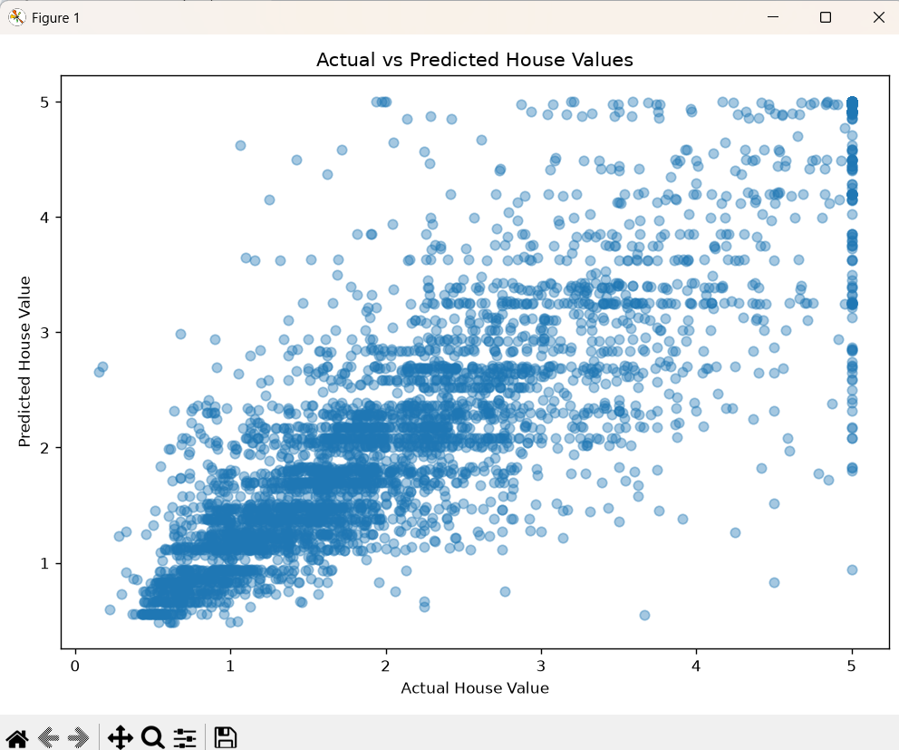

Figure 8 output:
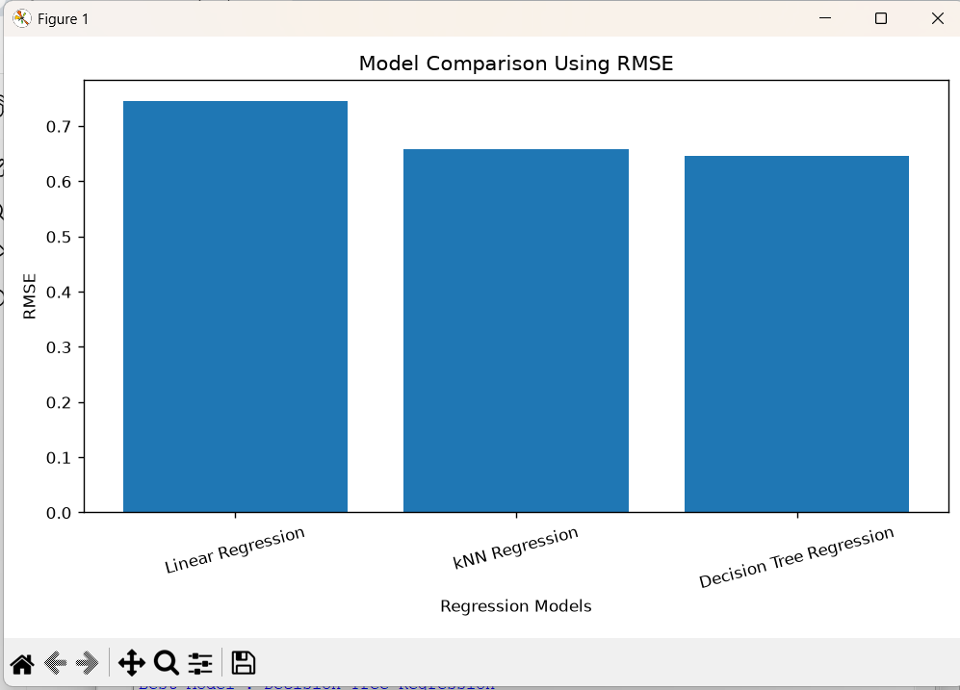

Figure 9 output:
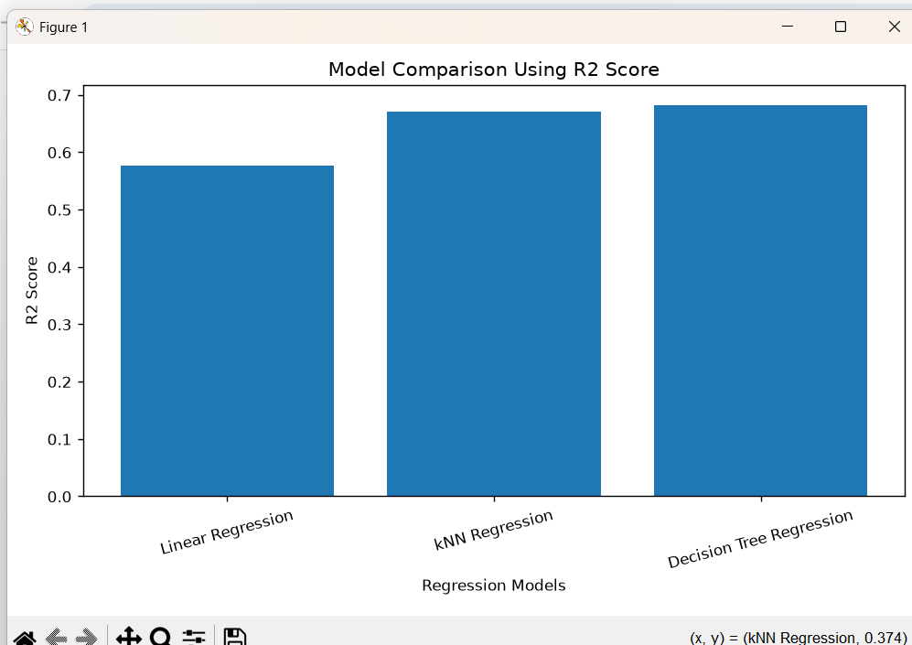
10. K-MEANS CLUSTERING AND PROPERTY MARKET SEGMENTATION
After completing house-price prediction, K-Means clustering was applied to identify groups of properties with similar characteristics. K-Means is an unsupervised learning technique that divides the properties into different clusters based on selected numerical attributes such as income, house age, rooms, occupancy, location, and house value.
10.1 Selection of Number of Clusters
Different values of K were evaluated using a suitable clustering evaluation method such as the Silhouette Score. The value of K producing a suitable clustering structure was selected for the final analysis. The selected K should provide meaningful and distinguishable property groups.
10.2 Property Segmentation
The resulting clusters were analyzed based on their average property characteristics and house values. The clusters can be interpreted as different market segments such as:
- Budget Properties – properties with relatively lower house values.
- Mid-Range Properties – properties with moderate house values and characteristics.
- Premium Properties – properties with relatively higher house values and favourable characteristics.
The exact cluster labels and interpretations are assigned based on the actual clustering results obtained from the Python implementation.
10.3 Cluster Analysis
A cluster summary table was prepared to compare the average characteristics of each property group. The clusters were also compared with predicted house prices from the selected regression model. This provides an integrated view of both predicted property value and market segment.
10.4 Interpretation
The clustering results help the real-estate organization understand the structure of the property market. Identifying groups of similar properties can support targeted valuation, market analysis, property classification, and better decision-making. The assignment specifically requires K-Means implementation, justification of K, visualization, and interpretation of property clusters.
11. FINAL OBSERVATIONS AND CONCLUSION
The House Price Prediction and Property Market Segmentation System successfully demonstrates an end-to-end Data Science workflow for analysing real-estate data. The dataset was first inspected and preprocessed to improve data quality and prepare the attributes for analysis. Exploratory Data Analysis and descriptive statistical techniques were then used to understand house-price distributions, relationships among property attributes, and possible outliers.
Three supervised regression algorithms, including Linear Regression, k-Nearest Neighbours Regression, and Decision Tree Regression, were applied to predict house prices. Their performance was evaluated using MAE, MSE, RMSE, and R², allowing the models to be compared and the best-performing model to be selected.
K-Means clustering was also applied to group properties with similar characteristics. The clusters were analysed according to property attributes and price levels to identify lower-value, mid-range, and high-value market segments. This supports the use of data-driven techniques for property valuation and market analysis.
Overall, the project shows how data preprocessing, statistical analysis, regression modelling, model evaluation, and clustering can be integrated into a single practical solution. The resulting system can assist real-estate organisations in understanding property characteristics, estimating prices, and identifying meaningful market segments for better decision-making. The assignment specifically expects this complete workflow from data retrieval through recommendations.

12. DATA-DRIVEN PROPERTY MARKET AND VALUATION RECOMMENDATIONS
Based on the statistical analysis, regression results, and K-Means clustering, the following recommendations can be made:
- Use data-based valuation: Property prices should be estimated using important attributes such as income level, house age, room characteristics, location, and other relevant numerical factors.
- Use the best-performing regression model: The model with the lowest RMSE and MAE and a comparatively higher R² score should be preferred for practical house-price prediction.
- Use market segmentation: Properties can be divided into lower-value, mid-range, and premium segments based on their cluster characteristics and average prices.
- Support property buyers: Buyers can use the predicted price and property segment to compare properties and identify suitable options within their budget.
- Support sellers and real-estate organisations: Sellers can use model-based price estimates and cluster information to set more reasonable prices and understand the target market.
- Identify high-value properties: Properties belonging to high-value clusters can be analysed separately for premium marketing, investment opportunities, and specialised valuation.
- Regularly update the model: As property markets change over time, new property data should be incorporated periodically to maintain prediction accuracy.
These recommendations use the final results for property valuation and market segmentation, as required by the assignment.
13. SDG RELEVANCE AND LEARNING OUTCOMES
13.1 SDG Relevance
This project is relevant to the following Sustainable Development Goals:
- SDG 8 – Decent Work and Economic Growth: The system supports efficient property valuation and data-driven real-estate decision-making, contributing to informed economic activities.
- SDG 9 – Industry, Innovation and Infrastructure: The project applies Data Science and Machine Learning techniques to develop an analytical solution for the real-estate sector.
- SDG 12 – Responsible Consumption and Production: Data-based property analysis can support better utilisation of resources and more informed property-related decisions.
The assignment officially maps the project to SDG 8, SDG 9, and SDG 12.
13.2 Learning Outcomes
Through this project, the following learning outcomes were achieved:
- Understood the complete Data Science workflow from data retrieval to final recommendations.
- Applied Pandas and NumPy for data preprocessing and manipulation.
- Used Matplotlib for exploratory data visualization.
- Applied descriptive statistics such as mean, variance, covariance, and correlation.
- Performed statistical inference using confidence interval estimation.
- Implemented and evaluated Linear Regression, kNN Regression, and Decision Tree Regression.
- Compared machine-learning models using MAE, MSE, RMSE, and R².
- Applied K-Means clustering for property market segmentation.
- Interpreted analytical results to provide data-driven recommendations.
- Developed an end-to-end Data Science solution for a real-world property analysis problem.
The project directly covers preprocessing, EDA, statistical analysis, regression, evaluation, and K-Means clustering specified in the assignment.
One page Write up:

14. INDIVIDUAL CONTRIBUTION REPORT
I contributed to the development of the House Price Prediction and Property Market Segmentation System by participating in data preprocessing, exploratory data analysis, statistical analysis, machine learning, and result interpretation.
My contribution included preparing the dataset, analysing important property attributes, implementing regression models for house-price prediction, comparing model performance, and supporting the K-Means clustering process for property segmentation. I also contributed to preparing visualizations, interpreting the results, and documenting the final observations and recommendations.
Through this assignment, I gained practical knowledge of Python, Pandas, NumPy, Matplotlib, Scikit-learn, regression, statistical analysis, model evaluation, and K-Means clustering. The work helped me understand how Data Science techniques can be applied to solve real-world property valuation and market analysis problems.
Student Name: N. Hemanth Reddy
Roll No.: _______192472215___________
Signature: __hemanth reddy________________

